TITLE
AUTOMATED COOLING PAD
FIELD OF INVENTION
Sensors

BACKGROUND AND PROBLEM IN THE PRIOR ART
A cooling pad is an accessory for laptops that helps to reduce their operating temperature, which is normally used when the laptop is unable to sufficiently cool itself. Laptop coolers are intended to protect the laptop from overheating as well as the user from suffering heat related discomfort. Cooling pads uses Buttons or Scroll wheel for adjusting the rotation speed of the fan. The Following Invention solves this problem by using Temperature Sensor (DHT11 Sensor), which Automatically Increases the fan speed when Temperature rises and Decreases the fan speed when the temperature falls.

The few researches allied to the above said inventions are listed below:

Patent No: CN201120399298XU The utility model discloses a laptop heat dispersion base including a base plate, base plate supporting legs and a cooler fixed on the bottom of the base plate. The laptop heat dispersion base is characterized in that a laptop heat transfer pad is arranged on the base plate, the laptop heat transfer pad is in seal connection with the base plate to form a sealing cavity, and the sealing cavity is instilled with liquid coolant. A sealing cavity is filled with liquid coolant and formed by the heat transfer pad and the base plate, and the liquid coolant absorbs heat generated by a laptop on the rubber. And, the cooler cools down the temperature of the liquid coolant to realize the high heat dispersion efficiency ensure the operation speed of the laptop, and indirectly prolong the service lifetime.

Patent No: KR1020050016492A, The present invention is formed by combining a cooling plate on the upper side of the pedestal body, the cooling plate is formed of a metal material, the electronic cooling element is attached to the bottom of the pedestal body, the outside air is sucked by the operation of the blower fan installed inside the pedestal body Cooling plate for notebook type personal computer that cools the cooling plate and the electronic cooling element while flowing in between the base body and the cooling plate through the ball and discharged through the discharge hole. It collects and cools the cooling plate and electronic cooling element made of metal, and cools the cooling plate and the electronic cooling element by external air introduced from the outside, thereby improving the thermal conductivity and cooling effect, and consisting of the pedestal body and the cooling plate. It forms a path through which external air is introduced into and discharged from the cooling stand, so that the outside air does not collide with the suction and discharge. Improves the cooling efficiency, and because the outside air sucked into the cooling stand is not temporarily discharged by the horizontal and vertical support formed in the interior of the pedestal body, it is possible to improve the cooling efficiency. Since the first half is inclined forward from the side, the notebook can be used more easily and comfortably.

Patent No:KR1020160130314A, The present invention relates to a portable laptop computer cooling pad, moving a heated laptop computer to a position of a cooling fan when the laptop computer is used, to efficiently cool the laptop computer, thereby solving a problem of not properly performing cooling in use since heating parts of existing laptop computers are different. Accordingly, the portable laptop computer cooling pad comprises: a pad body formed in a shape capable of fixating a laptop computer there onto; a moving rail formed in a moving rail shape to freely move a cooling fan; and the cooling fan formed in a shape capable of cooling heat of the laptop computer, being detachable attached, and discharging wind. Accordingly, since a heated laptop computer is moved to a position of a cooling fan when the laptop computer is used, the laptop computer is able to be efficiently cooled, thereby providing an effect of solving a problem of not properly performing cooling in use since heated parts of existing laptop computers are different.

The above stated abstract of the individual patent provides solution for the new design construction, theory about the Automated Cooling Pad.

Using an external cooling pad will help sustain the performance of your laptop. Most recent laptops with high-end processors generate excessive heat, which if not dissipated out, results in CPU throttling ( low frame rates for games).Laptop cooling pads work especially well for gaming. This is one of the most common use cases for laptop cooling pads, since running games on your computer can be labor intensive for laptops , which typically offers faster processing power to support your gaming needs. Cooling pads uses Buttons or Scroll wheel for adjusting the rotation speed of the fan. This Problem can be easily overcome by using proper sensors.

The novel features of this invention are:
- Cooling pads uses Buttons or Scroll wheel for adjusting the rotation speed of the fan. The Following Invention solves this problem by using Temperature Sensor (DHT11 Sensor), which Automatically Increases the fan speed when Temperature rises and Decreases the fan speed when the temperature falls.
- The proposed system is integrated with Arduino System.

OBJECT OF INVENTION
- The Automated Cooling Pad, which Automatically Increases the fan speed when Temperature rises and Decreases the fan speed when the temperature falls .
- The Arduino system in the Cooling pad will help us to integrate the Sensor and LCD display into Automated Cooling Pad.

SUMMARY OF THE INVENTION
A cooling pad is an accessory for laptops that helps to reduce their operating temperature, which is normally used when the laptop is unable to sufficiently cool itself. Laptop coolers are intended to protect the laptop from overheating as well as the user from suffering heat related discomfort. Using an external cooling pad will help sustain the performance of your laptop. Most recent laptops with high-end processors generate excessive heat, which if not dissipated out, results in CPU throttling ( low frame rates for games).Laptop cooling pads work especially well for gaming. This is one of the most common use cases for laptop cooling pads, since running games on your computer can be labor intensive for laptops , which typically offers faster processing power to support your gaming needs. Cooling pads uses Buttons or Scroll wheel for adjusting the rotation speed of the fan. The Following Invention solves this problem by using Temperature Sensor (DHT11 Sensor), which Automatically Increases the fan speed when Temperature rises and Decreases the fan speed when the temperature falls.

BRIEF DESCRIPTION OF DRAWING

FIG. 1 represents the overview of the invention
FIG. 2 represents the Simulated Diagram of the Automated Cooling Pad

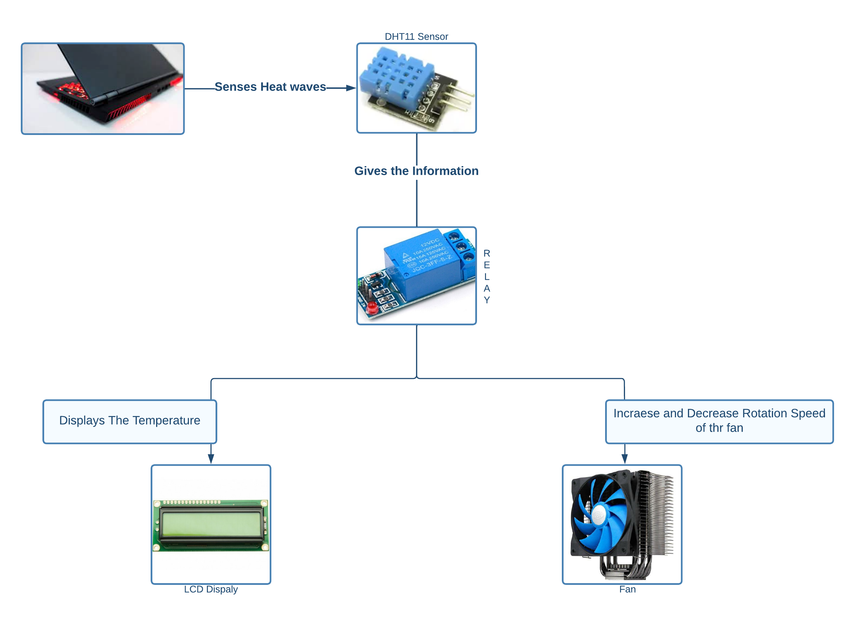

FIG.1 OVERVIEW OF THE INVENTION
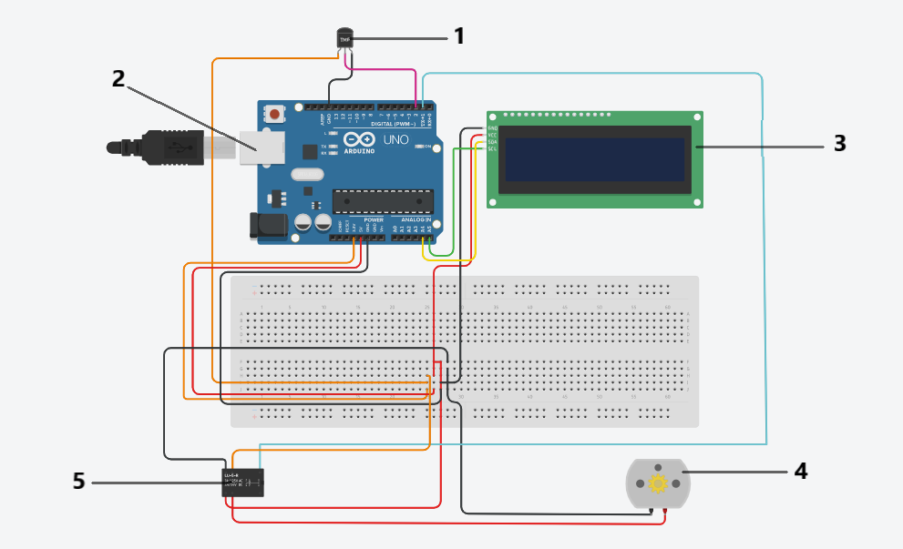

FIG.2. SIMULATED DIAGRAM OF THE AUTOMATED COOLING PAD

DETAILED DESCRIPTION OF THE DRAWING

FIG.1. Cooling pads uses Buttons or Scroll wheel for adjusting the rotation speed of the fan. The Automated Cooling Pad solves this problem by using Temperature Sensor (DHT11 Sensor), which Automatically Increases the fan speed when Temperature rises and Decreases the fan speed when the temperature falls.

FIG.2. In this invention we used Arduino UNO[2] because its simple and accessible user experience. The Arduino software is used to use for beginners and flexible enough for advanced users. LCD Display[3] is used to display the temperature sensed by DHT11 Sensor[1]. Relay[5] is an electrically operated switch used to change the rotation speed of the DC Motor(Fan)[4].

DETAILED DESCRIPTION OF THE INVENTION

DHT11 Sensor is integrated to Sense the heat released by the Laptop. For measuring temperature this sensor uses Negative Temperature coefficient thermistor. The DHT11 sensor is coupled with Fan using relay. The relay will change the rotating speed of the fan based on the temperature sensed by the DHT11 sensor. When the temperature is above 60℃, the fan will be at its highest speed. When the temperature is between 40℃ to 60℃, the fan will be at its medium speed. When the temperature is less than 40℃, the fan will be at its lowest speed. When the laptop is turned off, the sensor will stop sensing and the fan will turn off. This will be user friendly, which will be convenient for the user to experience lag free performance.

TECHNICAL DETAILS
The experimental protocol for this project is designed and described as follows:
Implementation of Node MCU, DHT11 sensor to sense the temperature, LCD display for viewing and Fan integrated to the sensor system.
S.No. | Activity
1. | Implementation of sensor
2. | Sense the temperature
3. | Fan integrated with relay to change the rotation speed

CLAIMS
We claim,
[CLAIM 1] Sensors to sense the temperature.
[CLAIM 2] Fan integrated with relay to change the rotation speed.

ABSTRACT
Laptop cooling pads work especially well for gaming. This is one of the most common use cases for laptop cooling pads, since running games on your computer can be labor intensive for laptops , which typically offers faster processing power to support your gaming needs. A cooling pad is an accessory for laptops that helps to reduce their operating temperature, which is normally used when the laptop is unable to sufficiently cool itself. Laptop coolers are intended to protect the laptop from overheating as well as the user from suffering heat related discomfort. Cooling pads uses Buttons or Scroll wheel for adjusting the rotation speed of the fan. The Following Invention solves this problem by using Temperature Sensor (DHT11 Sensor), which Automatically Increases the fan speed when Temperature rises and Decreases the fan speed when the temperature falls.

